ANA-050 Functional Specification
Simpsons Beverages: Auto Attach Recipe Specification and Density Information to Pack V1.0

Document Properties
Authors | Eshan Fernando | Infor M3 Consultant

Approvers | Joe Walker | Solution Architect | Date: 01/12/2025
Approvers | Bevon Raj | Senior Consultant | Date: 01/12/2025

Change Control | Eshan Fernando | Creation | Date: 13/01/2026
Change Control |  |  | Date

Contents
ANA-050 Functional Specification 1
Document Properties 1
Contents 1
Introduction 2
Functional Overview 2
Current process 2
Proposed process 2
Below is the sequence in which APIs are executed. 4
Assumptions & Limitations 17

Introduction
This ANA-050 Functional Specification provides a functional solution for the Auto Attach Recipe Specification and Density Information to Pack V1.0 requested by Simpsons Beverages.
It is not intended to provide technical information. Any supporting technical information can be found in the accompanying ‘TAR-040 Technical Specification’ document, if provided.

The primary objective of this specification is to provide a functional overview of a solution to the proposed modification.

It does not consist of any training material that explains to a detailed level how the deliverables form the functional solution. It is expected that the reader of this document is to have a good understanding of any Infor M3 programs mentioned within this specification.

Functional Overview

Current process
Certain information that is pushed from PLM to M3 regarding recipe items will be relevant for pack items. Currently this information needs maintaining manually in M3 which is additional work for the team. Information such as recipe tests and density information relevant for the pack item will need to be manually attached to the pack item once the recipe item is added to the pack Bill of Material (BoM).

Proposed process
Once a recipe item is attached to a pack BOM and a button clicked in PDS002/U1 screen, recipe item specification header and tests will be automatically attached to the pack item, density information on the recipe item will be multiplied based on pack size and attached to the pack item.

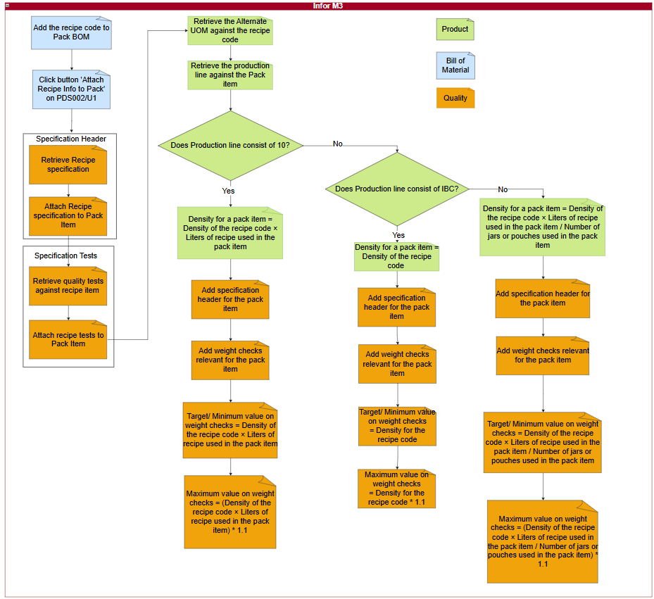
Figure 1: Information on recipes that are relevant for pack items automatically attached.
There will be a button on display in PDS002/U1 which needs to be clicked once the recipe item is added to the BoM and is selected.

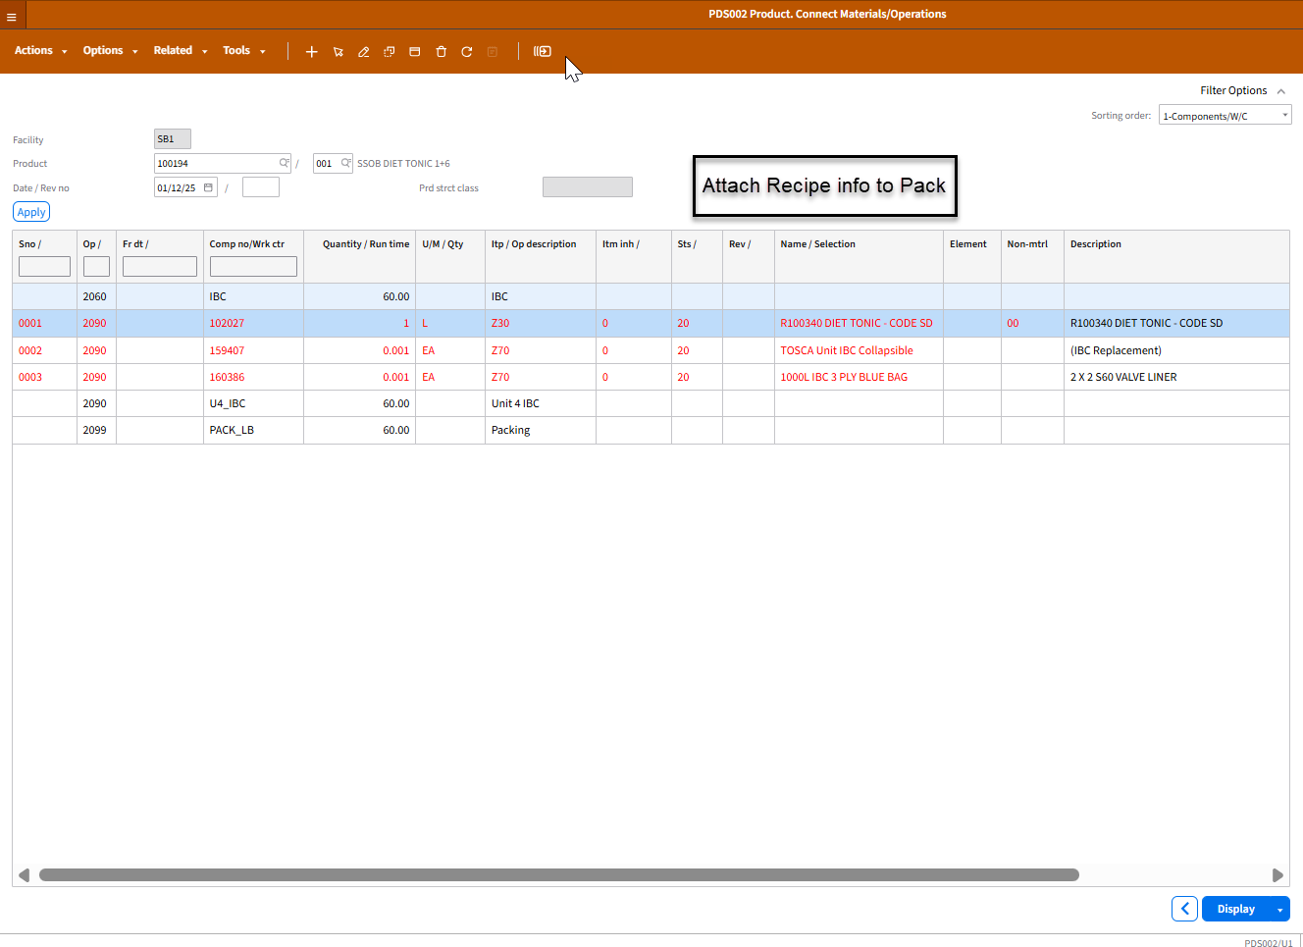
Figure 2: Recipe item selected in PDS002/U1
It will then execute below APIs in sequence and ensure information on recipe item is attached to the pack item.

Below is the sequence in which APIs are executed.

Step 01: Attaching the recipe specification to pack item

Step 01.01. Retrieving the specification header for the recipe item.
  - API: QMS200MI
  - Transaction: LstSpecsbyItem
Description | Field | Test Value | Extraction Method
Item number | ITNO | 153228 | Recipe item selected in PDS002/U1
Table 1: Retrieve specification header for the recipe item.
Based on inputs to Table 1, below outputs are obtained.

Description | Field | Test Value
Specification | SPEC | 153228
Effective date | QSE1 | 20240101
Inactive date | QSI1 | 20301231
Description | TX40 | 153228 Recipe Check
Status | STAT | 20
Auto attach | AUAT | 1
Retest | SRTT | 1
Reclass | SRCL | 1
Laboratory Manager | SPAN | EFERNANDO
Number of copies | NBEX | 1
Table 2: Output retrieved for the recipe item specification.

Step 01.02. Attach specification header record on the recipe item to the pack item
  - API: QMS200MI
  - Transaction: AddSpec
Description | Field | Test Value | Extraction Method
Item number | ITNO | 100194 | Product code relating to the recipe selected in PDS002/U1
Specification | SPEC | 153228 | Output from Table 2
Effective date | QSE1 | 20240101 | Output from Table 2
Inactive date | QSI1 | 20301231 | Output from Table 2
Description | TX40 | 153228 Recipe Check | Output from Table 2
Status | STAT | 20 | Output from Table 2
Auto attach | AUAT | 1 | Output from Table 2
Retest | SRTT | 1 | Output from Table 2
Reclass | SRCL | 1 | Output from Table 2
Laboratory Manager | SPAN | EFERNANDO | Output from Table 2
Number of copies | NBEX | 1 | Output from Table 2
Table 3: Add Recipe specification against the pack item.

Step 02: Attaching tests to the recipe specification attached to pack item

Step 02.01. Retrieve specification tests relating to the specification header for the recipe item.
  - API: QMS201MI
  - Transaction: LstSpecTest
Description | Field | Test Value | Extraction Method
Specification | SPEC | 153228 | Output from Table 2
Effective date | QSE1 | 20240101 | Output from Table 2
Item number | ITNO | 153228 | Input to Table 1
Table 4: Retrieve specification tests relating to the recipe item.
Based on inputs to Table 4, below outputs are obtained. There will be multiple records retrieved as part of this API call.

Description | Field | Test Value
Test | QTST | DENSITY
Test type | TSTY | 0
Effective date | QTE1 | 20240101
Inactive date | QTI1 | 20301231
Description | TX40 | Density
Test order | EXSQ | 1
Test result | QLCD
Expected value max | EVMX | 1.064
Expected value min | EVMN | 1.024
Expected target value | EVTG | 1.024
Test U/M | TEUM | KGL
Number of decimal places | DCCD | 5
Required | REQD | 1
Frequency times | FRTI | 1
Test classification | TCLS
Value setup | VLTP | 1
Test priority | QTSP | 1
Include test in QI request | ITQR | 1
Print test on certificate of analysis | PTCA | 1
Print test on specification document | PTSP | 1
Print spec test values | QPTT | 1
Print result value | QPTR | 1
Specification approval basis | QPLN | 9
Table 5: Output retrieved for the specification tests for recipe item.

Step 02. 02. Add specification tests to the specification in a loop for each record retrieved from Table 5
  - API: QMS201MI
  - Transaction: AddSpecTest
Description | Field | Test Value | Extraction Method
Specification | SPEC | 153228 | Input to Table 2
Effective date | QSE1 | 20240101 | Output from Table 5
Item number | ITNO | 100194 | Product code relating to the recipe selected in PDS002/U1
Test | QTST | DENSITY | Output from Table 5
Test type | TSTY | 0 | Output from Table 5
Effective date | QTE1 | 20240101 | Output from Table 5
Inactive date | QTI1 | 20301231 | Output from Table 5
Description | TX40 | Density | Output from Table 5
Test order | EXSQ | 1 | Output from Table 5
Test result | QLCD |  | Output from Table 5
Expected value max | EVMX | 1.064 | Output from Table 5
Expected value min | EVMN | 1.024 | Output from Table 5
Expected target value | EVTG | 1.024 | Output from Table 5
Test U/M | TEUM | KGL | Output from Table 5
Number of decimal places | DCCD | 5 | Output from Table 5
Required | REQD | 1 | Output from Table 5
Frequency times | FRTI | 1 | Output from Table 5
Test classification | TCLS |  | Output from Table 5
Value setup | VLTP | 1 | Output from Table 5
Test priority | QTSP | 1 | Output from Table 5
Include test in QI request | ITQR | 1 | Output from Table 5
Print test on certificate of analysis | PTCA | 1 | Output from Table 5
Print test on specification document | PTSP | 1 | Output from Table 5
Print spec test values | QPTT | 1 | Output from Table 5
Print result value | QPTR | 1 | Output from Table 5
Specification approval basis | QPLN | 9 | Output from Table 5
Table 6: Adding specification tests relating to the specification.

Step 03: Adding density against the pack item

Step 03. 01. Retrieving the alternate UOM on the recipe item.
  - API: MMS015MI
  - Transaction: Get
Description | Field | Test Value | Extraction Method
Item number | ITNO | 153228 | Input to Table 1
Alternate U/M type | AUTP | 1 | Configurable field in the parameter file
Alternate U/M | ALUN | KG | Configurable field in the parameter file
Table 7: Inputs to retrieve unit of measure conversion between Kilograms and Liters on the recipe item.
Description | Field | Test Value
Conversion factor | COFA | 1.032
Conversion form | DMCF | 2
Table 8: Conversion factor and conversion form for the recipe item.
Once the conversion factor (COFA) is retrieved for the recipe item, it needs to be adjusted to calculate density against the pack item based on the production line being 10L, IBC or any other.

Step 03. 02. Retrieving the production line against the pack item.
- API: MMS200MI
  - Transaction: GetItmFac
Description | Field | Test Value | Extraction Method
Company | CONO | 680 | Maintain as a configurable field in the parameter file
Facility | FACI | SB1 | Maintain as a configurable field in the parameter file
Item Number | ITNO | 153224 | Product code relating to the recipe selected in PDS002/U1
Table 9: Inputs to extract the production line for the pack item
Description | Field | Test Value
Production line | WCLN | 10L_A
Table 10: Production line against the pack item.

Step 03. 03. Adding the alternate UOM against the pack item.

Step 03. 03. 01. Production line on Table 10 consist of 10 (i.e. 10L_A, 10L_B, 10L_C, U4_10LCD).

Step 03. 03. 01. 01. Extract quantity against the recipe code
  - API: CMS100MI
  - Transaction: LstMaterial
Description | Field | Test Value | Extraction Method
From Item to inherit | F_INHI | 1 | Maintain as a configurable field in the parameter file
To item to inherit | T_INHI | 1 | Maintain as a configurable field in the parameter file
Facility | FACI | SB1 | Maintain as a configurable field in the parameter file
Product | ITNO | 102757 | Product code relating to the recipe selected in PDS002/U1
Structure type | STRT | 001 | Maintain as a configurable field in the parameter file
Table 11: Inputs to extract the consumption quantity against the recipe code
Description | Field | Test Value
Quantity | CNQT | 20
Table 12: Consumption quantity against the recipe code.

Step 03. 03. 01. 02. Add density against the pack code
  - API: MMS015MI
  - Transaction: Add
Description | Field | Test Value | Extraction Method
Item number | ITNO | 153224 | Product code relating to the recipe selected in PDS002/U1
Alternate U/M type | AUTP | 1 | Configurable field in the parameter file
Alternate U/M | ALUN | KG | Configurable field in the parameter file
Number of decimal places | DCCD | 6 | Configurable field in the parameter file
Conversion factor | COFA | 20.64 | Conversion factor (COFA) on Table 8 * CNQT value on Table 12
Conversion form | DMCF | 2 | Output from Table 8
Standard U/M - Manufacturing | AUS3 | 1 | Configurable field in the parameter file
Table 13: Inputs to add unit of measure conversion between Kilograms and Liters against pack item.

Step 03. 03. 01. 03. Add specification header to the pack item so that weight checks can be added against the pack item.
  - API: QMS200MI
  - Transaction: AddSpec
Description | Field | Test Value | Extraction Method
Item number | ITNO | 100194 | Product code relating to the recipe selected in PDS002/U1
Specification | SPEC | 100194 | Product code relating to the recipe selected in PDS002/U1
Effective date | QSE1 | 20240101 | Configurable field in the parameter file
Inactive date | QSI1 | 20501231 | Configurable field in the parameter file
Description | TX40 | Pack Check | Configurable field in the parameter file
Status | STAT | 20 | Configurable field in the parameter file
Auto attach | AUAT | 1 | Configurable field in the parameter file
Retest | SRTT | 1 | Configurable field in the parameter file
Reclass | SRCL | 1 | Configurable field in the parameter file
Laboratory Manager | SPAN | EFERNANDO | Configurable field in the parameter file
Number of copies | NBEX | 1 | Configurable field in the parameter file
Table 14: Add Recipe specification against the pack item.

Step 03. 03. 01. 04. Specification tests relating to the pack item to the specification. This needs to be run in a loop 15 times for each of the weight checks.
  - API: QMS201MI
  - Transaction: AddSpecTest
Description | Field | Test Value | Extraction Method
Specification | SPEC | 100194 | Product code relating to the recipe selected in PDS002/U1
Effective date | QSE1 | 20240101 | Configurable field in the parameter file
Item number | ITNO | 100194 | Product code relating to the recipe selected in PDS002/U1
Test | QTST | WEIGHT-A | Configurable field in the parameter file. Needs to be executed in a loop with values from WEIGHT-A to WEIGHT-O (i.e. WEIGHT-A, WEIGHT-B, WEIGHT-C …..WEIGHT-O)
Test type | TSTY | 0 | Configurable field in the parameter file
Effective date | QTE1 | 20240101 | Configurable field in the parameter file
Inactive date | QTI1 | 20501231 | Configurable field in the parameter file
Description | TX40 | WEIGHT-A | Configurable field in the parameter file. Field input to be in a loop from WEIGHT-A to WEIGHT-O (i.e. WEIGHT-A, WEIGHT-B, WEIGHT-C, …..WEIGHT-O)
Test order | EXSQ | 1 | Configurable field in the parameter file
Test result | QLCD |  | Blank value
Expected value max | EVMX | 22.7 | Conversion factor (COFA) on Table 8 * CNQT value on Table 12 + 10%
Expected value min | EVMN | 20.64 | Conversion factor (COFA) on Table 8 * CNQT value on Table 12
Expected target value | EVTG | 20.64 | Conversion factor (COFA) on Table 8 * CNQT value on Table 12
Test U/M | TEUM | KG | Configurable field in the parameter file
Number of decimal places | DCCD | 5 | Configurable field in the parameter file
Required | REQD | 1 | Configurable field in the parameter file. First two records will be added with 1 being the input (WEIGHT-A and WEIGHT-B). Remaining thirteen records will be added with 0 being the input (WEIGHT-C, WEIGHT-D………..WEIGHT-O)
Frequency times | FRTI | 1 | Configurable field in the parameter file
Test classification | TCLS | PHYSICAL | Configurable field in the parameter file
Value setup | VLTP | 1 | Configurable field in the parameter file
Test priority | QTSP | 1 | Configurable field in the parameter file
Include test in QI request | ITQR | 1 | Configurable field in the parameter file
Print test on certificate of analysis | PTCA | 1 | Configurable field in the parameter file
Print test on specification document | PTSP | 1 | Configurable field in the parameter file
Print spec test values | QPTT | 1 | Configurable field in the parameter file
Print result value | QPTR | 1 | Configurable field in the parameter file
Specification approval basis | QPLN | 9 | Configurable field in the parameter file
Table 15: Adding specification tests relating to the pack item specification.
Weight check needs to be added to the pack specification 15 times in a loop starting from WEIGHT-A and ending with WEIGHT-O with values being WEIGHT-A, WEIGHT-B, WEIGHT-C,………….WEIGHT-O.

Step 03. 03. 02. Production line on Table 10 consist of any other value except 10 or IBC (i.e. 500ML, 5L_A, 5L_B).

Step 03. 03. 02. 01. Extract quantity against the recipe code
  - API: CMS100MI
  - Transaction: LstMaterial
Description | Field | Test Value | Extraction Method
From Item to inherit | F_INHI | 1 | Maintain as a configurable field in the parameter file
To item to inherit | T_INHI | 1 | Maintain as a configurable field in the parameter file
Facility | FACI | SB1 | Maintain as a configurable field in the parameter file
Product | ITNO | 102757 | Product code relating to the recipe selected in PDS002/U1
Structure type | STRT | 001 | Maintain as a configurable field in the parameter file
Table 16: Inputs to extract the consumption quantity against the recipe code
Description | Field | Test Value
Quantity | CNQT | 20
Table 17: Consumption quantity against the recipe code.

Step 03. 03. 02. 02. Extract quantity against the jar or pouch
  - API: CMS100MI
  - Transaction: LstMaterial
Description | Field | Test Value | Extraction Method
From Critical mtrl | F_CRTM | 1 | Maintain as a configurable field in the parameter file
To Critical mtrl | T_CRTM | 1 | Maintain as a configurable field in the parameter file
Facility | FACI | SB1 | Maintain as a configurable field in the parameter file
Product | ITNO | 102757 | Product code relating to the recipe selected in PDS002/U1
Structure type | STRT | 001 | Maintain as a configurable field in the parameter file
Table 18: Inputs to extract the consumption quantity against the jar or pouch
Description | Field | Test Value
Quantity | CNQT | 4
Table 19: Consumption quantity against the jar or pouch.

Step 03. 03. 02. 03. Add density against the pack code
  - API: MMS015MI
  - Transaction: Add
Description | Field | Test Value | Extraction Method
Item number | ITNO | 153224 | Product code relating to the recipe selected in PDS002/U1
Alternate U/M type | AUTP | 1 | Configurable field in the parameter file
Alternate U/M | ALUN | KG | Configurable field in the parameter file
Number of decimal places | DCCD | 6 | Configurable field in the parameter file
Conversion factor | COFA | 5.15 | Conversion factor (COFA) on Table 8 * CNQT value on Table 17/ CNQT value on Table 19
Conversion form | DMCF | 2 | Output from Table 8
Standard U/M - Manufacturing | AUS3 | 1 | Configurable field in the parameter file
Table 20: Inputs to add unit of measure conversion between Kilograms and Liters against pack item.

Step 03. 03. 02. 04. Add specification header to the pack item so that weight checks can be added against the pack item.
  - API: QMS200MI
  - Transaction: AddSpec
Description | Field | Test Value | Extraction Method
Item number | ITNO | 100194 | Product code relating to the recipe selected in PDS002/U1
Specification | SPEC | 100194 | Product code relating to the recipe selected in PDS002/U1
Effective date | QSE1 | 20240101 | Configurable field in the parameter file
Inactive date | QSI1 | 20501231 | Configurable field in the parameter file
Description | TX40 | Pack Check | Configurable field in the parameter file
Status | STAT | 20 | Configurable field in the parameter file
Auto attach | AUAT | 1 | Configurable field in the parameter file
Retest | SRTT | 1 | Configurable field in the parameter file
Reclass | SRCL | 1 | Configurable field in the parameter file
Laboratory Manager | SPAN | EFERNANDO | Configurable field in the parameter file
Number of copies | NBEX | 1 | Configurable field in the parameter file
Table 21: Add Recipe specification against the pack item.

Step 03. 03. 02. 05. Add specification tests relating to the pack item to the specification
  - API: QMS201MI
  - Transaction: AddSpecTest
Description | Field | Test Value | Extraction Method
Specification | SPEC | 100194 | Product code relating to the recipe selected in PDS002/U1
Effective date | QSE1 | 20240101 | Configurable field in the parameter file
Item number | ITNO | 100194 | Product code relating to the recipe selected in PDS002/U1
Test | QTST | WEIGHT-A | Configurable field in the parameter file. Needs to be executed in a loop with values from WEIGHT-A to WEIGHT-O (i.e. WEIGHT-A, WEIGHT-B, WEIGHT-C …..WEIGHT-O)
Test type | TSTY | 0 | Configurable field in the parameter file
Effective date | QTE1 | 20240101 | Configurable field in the parameter file
Inactive date | QTI1 | 20501231 | Configurable field in the parameter file
Description | TX40 | WEIGHT-A | Configurable field in the parameter file. Field input to be in a loop from WEIGHT-A to WEIGHT-O (i.e. WEIGHT-A, WEIGHT-B, WEIGHT-C, …..WEIGHT-O)
Test order | EXSQ | 1 | Configurable field in the parameter file
Test result | QLCD |  | Blank value
Expected value max | EVMX | 5.67 | Conversion factor (COFA) on Table 8 * CNQT value on Table 17/ CNQT value on Table 19 + 10%
Expected value min | EVMN | 5.15 | Conversion factor (COFA) on Table 8 * CNQT value on Table 17/ CNQT value on Table 19
Expected target value | EVTG | 5.15 | Conversion factor (COFA) on Table 8 * CNQT value on Table 17/ CNQT value on Table 19
Test U/M | TEUM | KG | Configurable field in the parameter file
Number of decimal places | DCCD | 5 | Configurable field in the parameter file
Required | REQD | 1 | Configurable field in the parameter file. First two records will be added with 1 being the input (WEIGHT-A and WEIGHT-B). Remaining thirteen records will be added with 0 being the input (WEIGHT-C, WEIGHT-D………..WEIGHT-O)
Frequency times | FRTI | 1 | Configurable field in the parameter file
Test classification | TCLS | PHYSICAL | Configurable field in the parameter file
Value setup | VLTP | 1 | Configurable field in the parameter file
Test priority | QTSP | 1 | Configurable field in the parameter file
Include test in QI request | ITQR | 1 | Configurable field in the parameter file
Print test on certificate of analysis | PTCA | 1 | Configurable field in the parameter file
Print test on specification document | PTSP | 1 | Configurable field in the parameter file
Print spec test values | QPTT | 1 | Configurable field in the parameter file
Print result value | QPTR | 1 | Configurable field in the parameter file
Specification approval basis | QPLN | 9 | Configurable field in the parameter file
Table 22: Adding specification tests relating to the pack item specification.
Weight check needs to be added to the pack specification 15 times in a loop starting from WEIGHT-A and ending with WEIGHT-O with values being WEIGHT-A, WEIGHT-B, WEIGHT-C,………….WEIGHT-O.

Step 03. 03. 03. In the event production line on Table 10 consist of a value containing IBC (i.e. IBC, U4_IBC).

Step 03. 03. 03. 01. Add density against the pack code
  - API: MMS015MI
  - Transaction: Add
Description | Field | Test Value | Extraction Method
Item number | ITNO | 153224 | Product code relating to the recipe selected in PDS002/U1
Alternate U/M type | AUTP | 1 | Configurable field in the parameter file
Alternate U/M | ALUN | KG | Configurable field in the parameter file
Number of decimal places | DCCD | 6 | Configurable field in the parameter file
Conversion factor | COFA | 1.032 | Conversion factor (COFA) on Table 8
Conversion form | DMCF | 2 | Output from Table 8
Standard U/M - Manufacturing | AUS3 | 1 | Configurable field in the parameter file
Table 23: Inputs to add unit of measure conversion between Kilograms and Liters against pack item.

Step 03. 03. 03. 02. Add specification header to the pack item so that weight checks can be added
  - API: QMS200MI
  - Transaction: AddSpec
Description | Field | Test Value | Extraction Method
Item number | ITNO | 100194 | Product code relating to the recipe selected in PDS002/U1
Specification | SPEC | 100194 | Product code relating to the recipe selected in PDS002/U1
Effective date | QSE1 | 20240101 | Configurable field in the parameter file
Inactive date | QSI1 | 20501231 | Configurable field in the parameter file
Description | TX40 | Pack Check | Configurable field in the parameter file
Status | STAT | 20 | Configurable field in the parameter file
Auto attach | AUAT | 1 | Configurable field in the parameter file
Retest | SRTT | 1 | Configurable field in the parameter file
Reclass | SRCL | 1 | Configurable field in the parameter file
Laboratory Manager | SPAN | EFERNANDO | Configurable field in the parameter file
Number of copies | NBEX | 1 | Configurable field in the parameter file
Table 24: Add Recipe specification against the pack item.

Step 03. 03. 03. 03. Add specification tests relating to the pack item to the specification
  - API: QMS201MI
  - Transaction: AddSpecTest
Description | Field | Test Value | Extraction Method
Specification | SPEC | 100194 | Product code relating to the recipe selected in PDS002/U1
Effective date | QSE1 | 20240101 | Configurable field in the parameter file
Item number | ITNO | 100194 | Product code relating to the recipe selected in PDS002/U1
Test | QTST | WEIGHT-A | Configurable field in the parameter file. Needs to be executed in a loop with values from WEIGHT-A to WEIGHT-O (i.e. WEIGHT-A, WEIGHT-B, WEIGHT-C …..WEIGHT-O)
Test type | TSTY | 0 | Configurable field in the parameter file
Effective date | QTE1 | 20240101 | Configurable field in the parameter file
Inactive date | QTI1 | 20501231 | Configurable field in the parameter file
Description | TX40 | WEIGHT-A | Configurable field in the parameter file. Field input to be in a loop from WEIGHT-A to WEIGHT-O (i.e. WEIGHT-A, WEIGHT-B, WEIGHT-C, …..WEIGHT-O)
Test order | EXSQ | 1 | Configurable field in the parameter file
Test result | QLCD |  | Blank value
Expected value max | EVMX | 1.136 | Conversion factor (COFA) on Table 8 + 10%
Expected value min | EVMN | 1.032 | Conversion factor (COFA) on Table 8
Expected target value | EVTG | 1.032 | Conversion factor (COFA) on Table 8
Test U/M | TEUM | KG | Configurable field in the parameter file
Number of decimal places | DCCD | 5 | Configurable field in the parameter file
Required | REQD | 1 | Configurable field in the parameter file. First two records will be added with 1 being the input (WEIGHT-A and WEIGHT-B). Remaining thirteen records will be added with 0 being the input (WEIGHT-C, WEIGHT-D………..WEIGHT-O)
Frequency times | FRTI | 1 | Configurable field in the parameter file
Test classification | TCLS | PHYSICAL | Configurable field in the parameter file
Value setup | VLTP | 1 | Configurable field in the parameter file
Test priority | QTSP | 1 | Configurable field in the parameter file
Include test in QI request | ITQR | 1 | Configurable field in the parameter file
Print test on certificate of analysis | PTCA | 1 | Configurable field in the parameter file
Print test on specification document | PTSP | 1 | Configurable field in the parameter file
Print spec test values | QPTT | 1 | Configurable field in the parameter file
Print result value | QPTR | 1 | Configurable field in the parameter file
Specification approval basis | QPLN | 9 | Configurable field in the parameter file
Table 25: Adding specification tests relating to the pack item specification.
Weight check needs to be added to the pack specification 15 times in a loop starting from WEIGHT-A and ending with WEIGHT-O with values being WEIGHT-A, WEIGHT-B, WEIGHT-C,………….WEIGHT-O.

Assumptions & Limitations
- A quality specification header and quality specification tests records exists in QMS200 and QMS201 against the recipe item.
- Recipe item is added correctly to the pack BOM with the correct consumption quantity.
- Recipe item is clicked on and selected in PDS002/U1 prior to clicking on the button.
- Quality specification and density information against the recipe item has already been transferred to Infor Cloudsuite from PLM.
- Quality specification against the pack item is always created in ’20-Approved’ state.

